man, to which this promise of sovereignty  
is given, is penetrated by the efficacy of  
Christ’s death) **taste of death** (some have  
seen in the phrase an allusion to the shortness and transitoriness of the Lord's death: so Chrysostom, “He properly said *should  
taste death,* and not, *should die*. For as  
if really only *tasting* it, He made so little  
stay in it, and immediately arose:” then,  
comparing Christ to a physician who first  
tastes his medicines to encourage the sick  
man to take them, adds, “So also Christ,  
since all men had ever been afraid of death,  
to persuade them to be bold against it, Himself tasted it, having no benefit so to do.” So also many other Commentators, among   
whom Beza and Bengel find also the *verity*  
of His Death indicated in the words. But  
it is well answered, that in none of the  
places where the phrase appears, either  
in the New Test. or in the rabbinical  
writings, does any such meaning appear  
to be conveyed. Nor again can we,  
as Bleek, understand the implication to  
be that Christ underwent all the *bitterness* of death. But the phrase falls into exact accord with the general argument  
of the passage, that it became Christ,  
in order to be the great and merciful  
High Priest of humanity, to be perfected  
through human sufferings: and it forms  
in fact the first mention of this idea,  
and prepares the way for **for** which follows. I would say, that the word **taste**  
must be regarded as slightly emphatic,  
and as implying the personal undergoing   
of death and entering into its suffering. And I doubt much, whether it will  
not be found that in the other passages where the phrase occurs, this personal suffering of death, though not boldly prominent, is yet within view, and agreeable to the context.

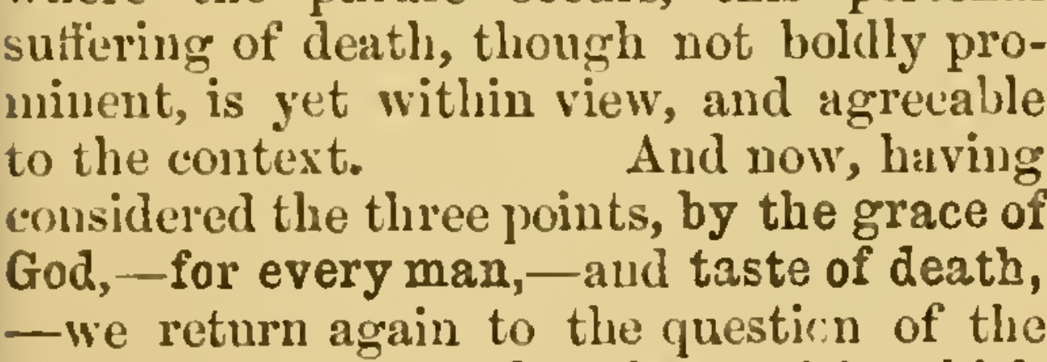

And now, having considered the three points, **by the grace of  
God,**—**for every man,**—and **taste of death,**  
—we return again to the question of the  
connexion of **in order that**, with which  
this clause begins. We before stated that  
we find it dependent on the former clause,  
*on account of His suffering of death crowned with glory and honour.* This  
exaltation, being the *perfecting* [see ver. 10] of Christ, was arrived at *through sufferings,* and *on account of His suffering of  
death*,—both by means of, and on account  
of, His suffering of death, And this exaltation has made Him the divine Head of our humanity—the channel of grace, and the  
Captain of our salvation. Without His  
exaltation, his death would not have been  
effectual. Unless he had been crowned  
with glory and honour, received to the  
right hand of the Father, and set in expectation of all things being put under his feet, His death could not have been, for  
every man, the expiation to him of his  
own individual sin. On the *triumphant issue*  
of his sufferings, their efficacy depends.  
And this I believe is what the Sacred  
Writer meant to express. His glory was  
the consequence of his suffering of death;  
—arrived at through His suffering: but  
the applicability of His death to every man  
is the consequence of His constitution in  
Heaven as the great High Priest, in virtue  
of his blood carried into the holy place,  
—and the triumphant Head of our common humanity: which common humanity  
of Him and ourselves now becomes the  
subject of further elucidation).

**10.] For** (the connexion with the foregoing,  
see above. The **for** renders a reason why  
the result just introduced should have  
been one which the *grace of God* contemplated) **it became** (as matter not only of decorum, but of sequence from the data;  
—*‘was suitable to,’* not as matter of absolute necessity, which was not the question here. The expression here glances at  
those who found in a suffering and crucified Messiah something unsuitable to the Godhead; and expresses not merely a  
negative, that it was not unsuitable, not  
unworthy of God,—but at the same time  
the positive, that it was altogether correspondent to and worthy of His Being and His Wisdom and His Love, to take this  
course: that it is so shaped, that he who  
knows the being and attributes of God,  
might have expected it. And thus it is  
indirectly implied, that it was also the  
most suitable, and that any other way  
would have been less correspondent to the  
being and purpose of God. Bleek has some  
excellent remarks on the lingering of the  
offence of the cross among these Jewish  
Christians, who, although their ideas of  
the glory and kingly triumph of the  
Messiah been in a measure satisfied  
by the resurrection and exaltation of Christ,  
and their hopes awakened by the promise  
of future glory at His second coming,—